VISVESVARAYA TECHNOLOGICAL UNIVERSITY

“JnanaSangama”, Belgaum -590014, Karnataka.


LAB REPORT

On

ANALYSIS AND DESIGN OF ALGORITHMS (23CS4PCADA)

Submitted by
Lopamudra Patro
(1WA24CS158)

in partial fulfillment for the award of the degree of BACHELOR OF ENGINEERING
in
COMPUTER SCIENCE AND ENGINEERING


B.M.S. COLLEGE OF ENGINEERING

(Autonomous Institution under VTU) BENGALURU-560019
February to June 2026

CERTIFICATE
B. M. S. College of Engineering,
Bull Temple Road, Bangalore 560019
(Affiliated To Visvesvaraya Technological University, Belgaum) Department of Computer Science and Engineering



This is to certify that the Lab work entitled “ANALYSIS AND DESIGN OF ALGORITHMS” carried out by Lopamudra Patro (1WA24CS158), who is bonafide student of B. M. S. College of Engineering. It is in partial fulfillment for the award of Bachelor of Engineering in Computer Science and Engineering of the Visvesvaraya Technological University, Belgaum during the year 2025-26. The Lab report has been approved as it satisfies the academic requirements in respect of Analysis and Design of Algorithms Lab - (23CS4PCADA) work prescribed for the said degree.

Ramya K M Dr. Kavitha Sooda
Assistant Professor Professor and Head
Department of CSE Department of CSE
BMSCE, Bengaluru BMSCE, Bengaluru

Index Sheet

Sl.  No. | Experiment Title | Page No.
1 | (a)Write program to obtain the Topological ordering of vertices in a given digraph.  (b)Leetcode Problem 207- Course schedule | 1 - 4
2 | Implement Johnson Trotter algorithm to generate permutations. | 5 - 6
3 | Sort a given set of N integer elements using Merge Sort technique and compute its time taken. Run the program for different values of N and record the time taken to sort. | 7 - 9
4 | Sort a given set of N integer elements using Quick Sort technique and compute its time taken. | 10 - 12
5 | Sort a given set of N integer elements using Heap Sort technique and compute its time taken. | 13 - 15
6 | (a)Implement 0/1 Knapsack problem using dynamic programming.  (b)Leetcode Problem 70 - Climbing Stairs | 16 - 18
7 | (a)Implement All Pair Shortest paths problem using Floyd’s algorithm.  (b)Leetcode Problem 1334 - Find the City With the Smallest Number of Neighbors at a Threshold Distance | 19 - 22
8 | - Find Minimum Cost Spanning Tree of a given undirected graph  using Prim’s algorithm.  - Find Minimum Cost Spanning Tree of a given undirected graph  using Kruskal’s algorithm. | 23 - 26
9 | Implement Fractional Knapsack using Greedy technique. | 27 - 28
10 | From a given vertex in a weighted connected graph, find shortest paths to  other vertices using Dijkstra’s algorithm. | 29 - 30
11 | Implement “N-Queens Problem” using Backtracking. | 31 - 32
12 | Leetcode exercises on Stacks, Queues, Circular Queues, Priority Queues. | 33 - 43
13 | Leetcode exercises on DFS, BFS | 44 - 48
14 | Leetcode exercises on Trees and Graphs | 49 - 53

Course outcomes:

CO1 | Analyze time complexity of algorithms using asymptotic notations.
CO2 | Apply various algorithm design techniques for the given problem.
CO3 | Evaluate appropriate algorithm/design technique for solving given problem.
CO4 | Conduct practical experiments by applying appropriate algorithm design technique to solve problems.

Lab program 1:
Write program to obtain the Topological ordering of vertices in a given digraph.

SOURCE CODE
#include <stdio.h> #include <stdlib.h> #include <time.h>
#define MAX 100
int adj[MAX][MAX]; int indegree[MAX]; int queue[MAX];
int n;
void topologicalSort()
{
int front = 0, rear = -1; int count = 0;
for(int i = 0; i < n; i++) indegree[i] = 0;
for(int i = 0; i < n; i++) for(int j = 0; j < n; j++)
if(adj[i][j] == 1) indegree[j]++;
for(int i = 0; i < n; i++) if(indegree[i] == 0)
queue[++rear] = i; printf("\nTopological Order: "); while(front <= rear)
{
int node = queue[front++]; printf("%d ", node); count++;
for(int i = 0; i < n; i++)
{
if(adj[node][i] == 1)
{
indegree[i]--; if(indegree[i] == 0)
queue[++rear] = i;
}
}
}
if(count != n)
printf("\nGraph has a cycle! No topological ordering possible.\n");
}

int main()
{
printf("Enter number of vertices: ");
scanf("%d", &n);
printf("Enter adjacency matrix:\n"); for(int i = 0; i < n; i++)
for(int j = 0; j < n; j++) scanf("%d", &adj[i][j]);
clock_t start = clock(); topologicalSort(); clock_t end = clock();
double time_taken = ((double)(end - start) / CLOCKS_PER_SEC) * 1000; printf("\n\nTime Taken = %.3f ms\n", time_taken);
return 0;
}

OUTPUT
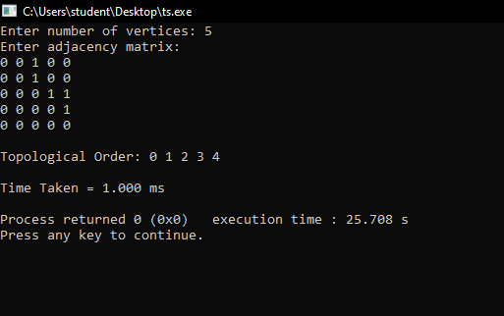

Leetcode Problem 207- Course schedule

bool canFinish(int numCourses, int** prerequisites, int prerequisitesSize, int* prerequisitesColSize)
{
int indegree[numCourses];
int adj[numCourses][numCourses];

for(int i=0;i<numCourses;i++)
{
indegree[i]=0;
for(int j=0;j<numCourses;j++) adj[i][j]=0;
}

for(int i=0;i<prerequisitesSize;i++)
{
int a=prerequisites[i][0]; int b=prerequisites[i][1];
adj[b][a]=1; indegree[a]++;
}

int queue[numCourses]; int front=0,rear=-1;
for(int i=0;i<numCourses;i++) if(indegree[i]==0)
queue[++rear]=i; int count=0;
while(front<=rear)
{
int u=queue[front++]; count++;

for(int v=0;v<numCourses;v++)
{
if(adj[u][v])
{
indegree[v]--;

if(indegree[v]==0) queue[++rear]=v;
}
}
}

return count==numCourses;
}

OUTPUT

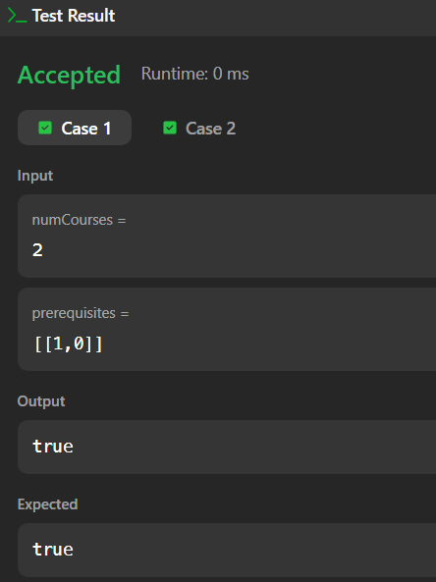
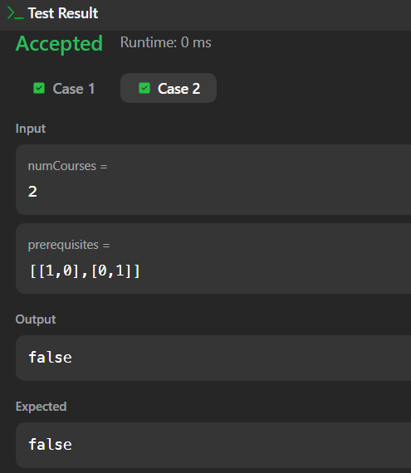
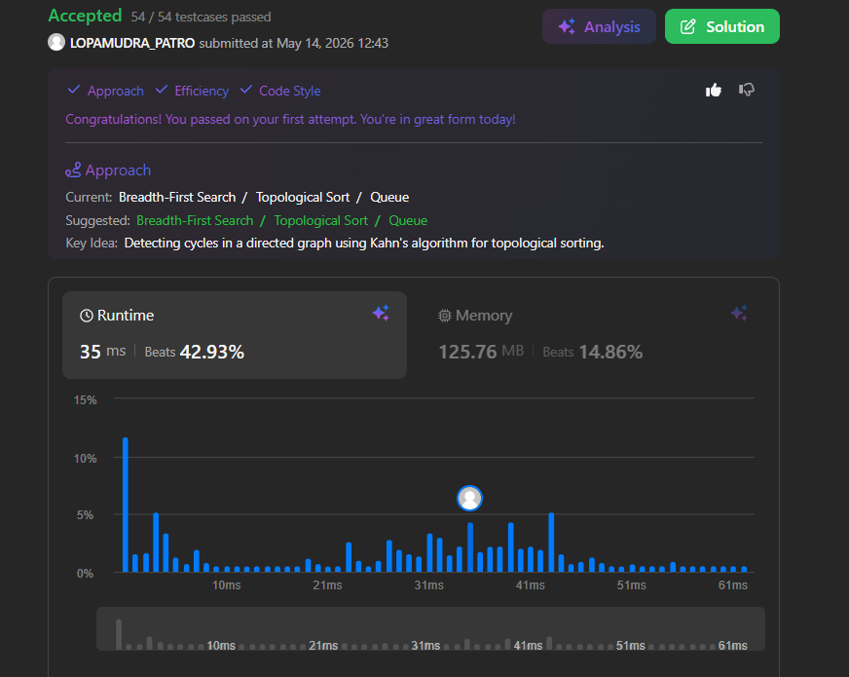

Lab program 2:
Implement Johnson Trotter algorithm to generate permutations.

SOURCE CODE
#include <stdio.h> #include <time.h> int a[10], dir[10]; void print(int n) {
for (int i = 0; i < n; i++) printf("%d ", a[i]);
printf("\n");
}

int mobile(int n) {
int m = 0, pos = -1;

for (int i = 0; i < n; i++) { int j = i + dir[i];

if (j >= 0 && j < n && a[i] > a[j] && a[i] > m) { m = a[i];
pos = i;
}
}
return pos;
}

int main() { int n;
printf("Enter number : "); scanf("%d", &n);
for (int i = 0; i < n; i++) { a[i] = i + 1;
dir[i] = -1;
}
clock_t start = clock(); print(n);
while (1) {
int i = mobile(n); if (i == -1)
break;
int j = i + dir[i]; int t = a[i];
a[i] = a[j]; a[j] = t;
t = dir[i];

dir[i] = dir[j]; dir[j] = t;
for (int k = 0; k < n; k++) if (a[k] > a[j])
dir[k] *= -1;
print(n);
}
clock_t end = clock();
double time_taken = ((double)(end - start) / CLOCKS_PER_SEC) * 1000; printf("\nTime Taken = %.3f ms\n", time_taken);
return 0;
}

OUTPUT
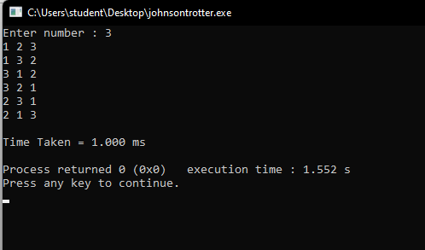

Lab program 3:
Sort a given set of N integer elements using Merge Sort technique and compute its time taken. Run the program for different values of N and record the time taken to sort.

SOURCE CODE

#include <stdio.h> #include <stdlib.h> #include <time.h>
int a[5000000], b[5000000];
void merge(int a[], int low, int mid, int high){ int i = low, j = mid + 1, k = low;
while(i <= mid && j <= high)
{
if(a[i] < a[j])
b[k++] = a[i++];
else
b[k++] = a[j++];
}
while(i <= mid) b[k++] = a[i++];
while(j <= high) b[k++] = a[j++];
for(int x = low; x <= high; x++) a[x] = b[x];
}
void merge_sort(int a[], int low, int high)
{
if(low < high)
{
int mid = (low + high) / 2; merge_sort(a, low, mid); merge_sort(a, mid + 1, high); merge(a, low, mid, high);
}
}
int main()
{
int n;
printf("Enter number of elements: "); scanf("%d", &n); srand(time(NULL)); printf("\nEntering the elements...\n"); for(int i = 0; i < n; i++)
{
a[i] = rand() % 1000;

printf("%d ", a[i]);
}
clock_t start_time = clock(); merge_sort(a, 0, n - 1); clock_t end_time = clock(); printf("\n\nAfter sorting:\n"); for(int i = 0; i < n; i++)
printf("%d ", a[i]); float total_time =
(float)(end_time - start_time) * 1000 / CLOCKS_PER_SEC; printf("\n\nTime taken = %.2f ms\n", total_time);
return 0;
}

OUTPUT
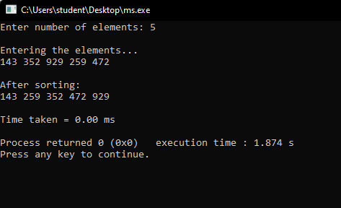
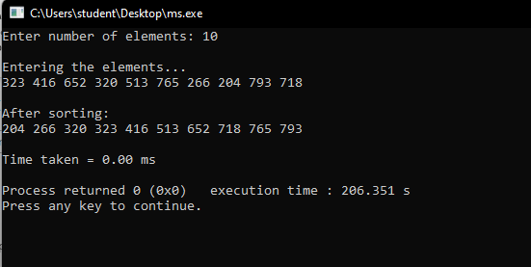

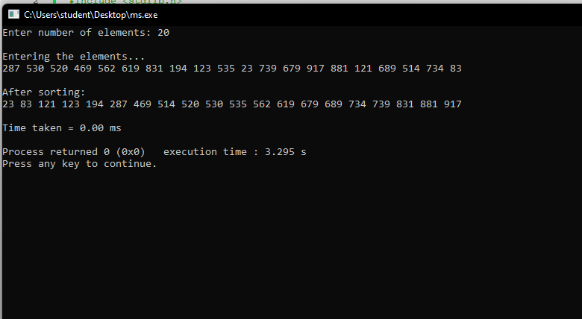

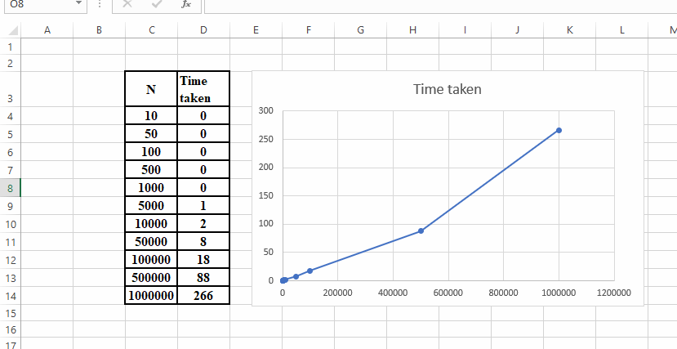
Time Taken for each N and Graph:

Lab program 4:
Sort a given set of N integer elements using Quick Sort technique and compute its time taken.

SOURCE CODE

#include <stdio.h> #include <stdlib.h> #include <time.h> int a[5000000];
void swap(int *a, int *b)
{
int temp = *a;
*a = *b;
*b = temp;
}
int partition(int a[], int low, int high)
{
int pivot = a[low]; int i = low + 1; int j = high; while (i <= j)
{
while (i <= high && a[i] <= pivot) i++;
while (j >= low && a[j] > pivot) j--;
if (i < j)
swap(&a[i], &a[j]);
}
swap(&a[low], &a[j]); return j;
}

void quick_sort(int a[], int low, int high)
{
if (low < high)
{
int j = partition(a, low, high); quick_sort(a, low, j - 1); quick_sort(a, j + 1, high);
}
}

int main()
{
int n;
printf("Enter number of elements: "); scanf("%d", &n);
srand(time(NULL)); printf("\nEntering elements...\n"); for (int i = 0; i < n; i++)
{
a[i] = rand() % 1000; printf("%d ", a[i]);
}
clock_t start = clock(); quick_sort(a, 0, n - 1); clock_t end = clock(); printf("\n\nAfter sorting:\n"); for (int i = 0; i < n; i++)
printf("%d ", a[i]);
double time_taken = ((double)(end - start) / CLOCKS_PER_SEC) * 1000; printf("\n\nTime taken: %.3f ms\n", time_taken);
return 0;
}

OUTPUT
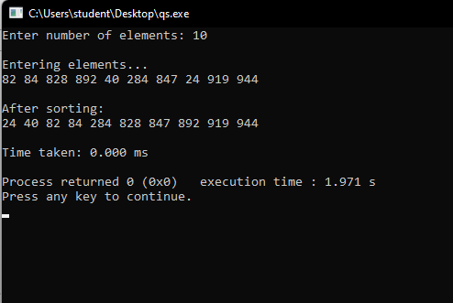

Time Taken for each N and Graph:

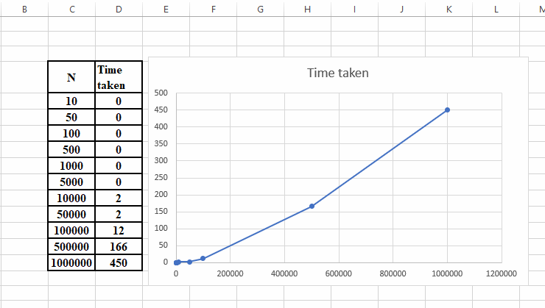

Lab program 5:
Sort a given set of N integer elements using Heap Sort technique and compute its time taken.

SOURCE CODE
#include <stdio.h> #include <stdlib.h> #include <time.h> int a[5000000];
void heapify(int a[], int i, int n)
{
int largest = i;
int left = 2 * i + 1; int right = 2 * i + 2;
if (left < n && a[left] > a[largest]) largest = left;
if (right < n && a[right] > a[largest]) largest = right;
if (largest != i)
{
int temp = a[i]; a[i] = a[largest]; a[largest] = temp;
heapify(a, largest, n);
}
}

void heap_sort(int a[], int n)
{
for (int i = n / 2 - 1; i >= 0; i--) heapify(a, i, n);
for (int i = n - 1; i > 0; i--)
{
int temp = a[0]; a[0] = a[i];
a[i] = temp; heapify(a, 0, i);
}
}

void print(int a[], int n)
{
for (int i = 0; i < n; i++) printf("%d ", a[i]);
printf("\n");
}

int main()
{
int n;
printf("Enter number of elements: "); scanf("%d", &n); srand(time(NULL)); printf("\nEntering elements...\n"); for (int i = 0; i < n; i++)
a[i] = rand() % 1000; print(a, n);
clock_t start = clock(); heap_sort(a, n); clock_t end = clock();
printf("\nAfter sorting:\n"); print(a, n);
double time_taken = ((double)(end - start) / CLOCKS_PER_SEC) * 1000; printf("\nTime taken: %.3f ms\n", time_taken);
return 0;
}

OUTPUT
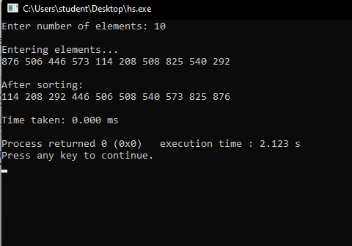

Time Taken for each N and Graph:
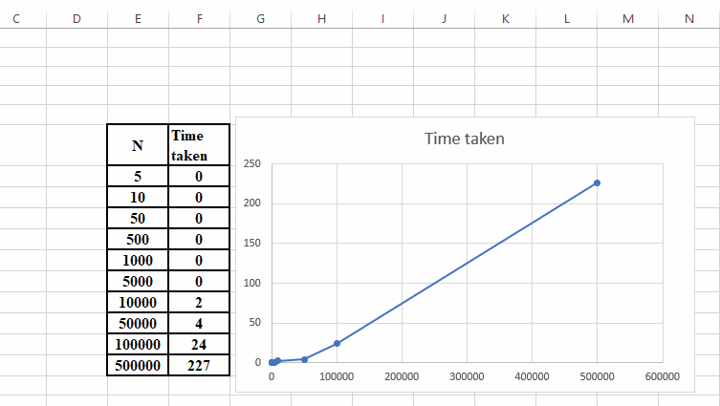

Lab program 6:
Implement 0/1 Knapsack problem using dynamic programming.

SOURCE CODE
#include <stdio.h> #include <time.h> int p[50],w[50],n,m; void inputs(){
printf("\nEnter number of items: "); scanf("%d",&n);
printf("\nEnter capacity: "); scanf("%d",&m); printf("\nEnter weights: "); for(int i=1;i<=n;i++)
scanf("%d",&w[i]); printf("\nEnter profits: "); for(int i=1;i<=n;i++)
scanf("%d",&p[i]);
}

int max(int a,int b){ return (a>b)?a:b;
}

int knapsack(){
int v[n+1][m+1]; for(int i=0;i<=n;i++){
for(int j=0;j<=m;j++){ if(i==0||j==0)
v[i][j]=0; else if(w[i]>j)
v[i][j]=v[i-1][j]; else
v[i][j]=max(v[i-1][j],v[i-1][j-w[i]]+p[i]);
}
}
printf("\nDP Table:\n") for(int i=0;i<=n;i++){
for(int j=0;j<=m;j++) printf("%4d",v[i][j]);
printf("\n");
}
printf("\nOptimal Profit: %d",v[n][m]);
}
int main(){ inputs();
clock_t start=clock();

knapsack();
clock_t end=clock();
float time_taken=((float)(end-start))/CLOCKS_PER_SEC*1000; printf("\nTime taken: %.3f ms",time_taken);
return 0;
}

OUTPUT

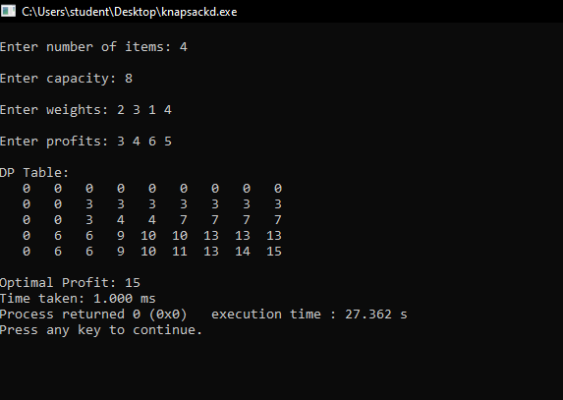

Leetcode Problem 70 - Climbing Stairs

int climbStairs(int n)
{
if(n <= 2) return n;
int a = 1, b = 2, c; for(int i = 3; i <= n; i++)
{
c = a + b;
a = b;
b = c;
}

return b;
}

OUTPUT

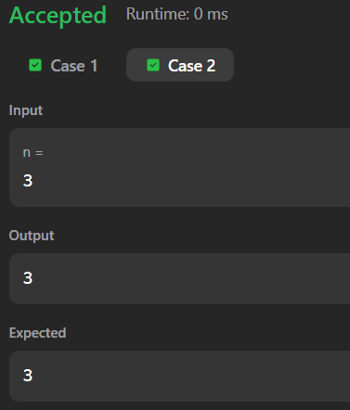
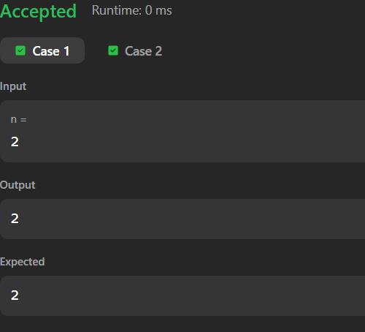
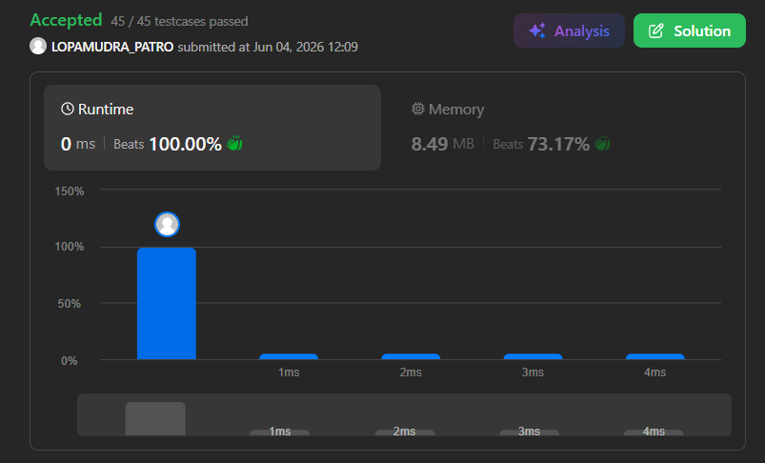

Lab program 7:
Implement All Pair Shortest paths problem using Floyd’s algorithm.

SOURCE CODE

#include <stdio.h> #include <time.h> #define INF 999 int main() {
int n;
printf("Enter number of vertices: "); scanf("%d", &n);
int graph[n][n];
printf("Enter adjacency matrix:\n");
printf("Enter 999 if no edge exists between vertices\n"); for (int i = 0; i < n; i++) {
for (int j = 0; j < n; j++) { scanf("%d", &graph[i][j]);
}
}
int d[n][n];
for (int i = 0; i < n; i++) for (int j = 0; j < n; j++)
d[i][j] = graph[i][j]; clock_t start = clock(); for (int i = 0; i < n; i++) {
for (int j = 0; j < n; j++) {
for (int k = 0; k < n; k++) {
if (d[j][i] + d[i][k] < d[j][k]) {
d[j][k] = d[j][i] + d[i][k];
}
}
}
}
clock_t end = clock(); printf("Shortest distance matrix:\n"); for (int i = 0; i < n; i++) {
for (int j = 0; j < n; j++) { printf("%d ", d[i][j]);
}
printf("\n");
}
float time_taken = ((float)(end - start) / CLOCKS_PER_SEC) * 1000; printf("\nTime taken: %.3f ms", time_taken);
return 0;
}

OUTPUT
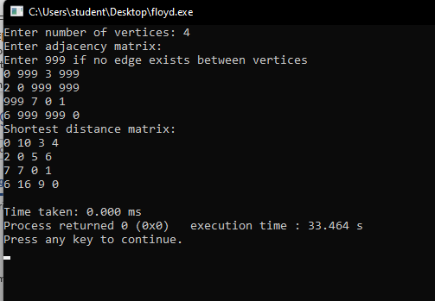

Leetcode Problem 1334 - Find the City With the Smallest Number of Neighbors at a Threshold Distance

#define INF 1000000
int findTheCity(int n, int** edges, int edgesSize, int* edgesColSize, int distanceThreshold)
{
int dist[n][n];
for(int i = 0; i < n; i++)
{
for(int j = 0; j < n; j++)
{
if(i == j) dist[i][j] = 0;
else
dist[i][j] = INF;
}
}
for(int i = 0; i < edgesSize; i++)
{
int u = edges[i][0]; int v = edges[i][1]; int w = edges[i][2]; dist[u][v] = w;
dist[v][u] = w;
}
for(int k = 0; k < n; k++)
{
for(int i = 0; i < n; i++)
{
for(int j = 0; j < n; j++)
{
if(dist[i][k] + dist[k][j] < dist[i][j])
dist[i][j] = dist[i][k] + dist[k][j];
}
}
}
int ans = -1;
int minReach = INF; for(int i = 0; i < n; i++)
{
int count = 0;
for(int j = 0; j < n; j++)
{
if(i != j && dist[i][j] <= distanceThreshold) count++;
}
if(count <= minReach)
{
minReach = count;

ans = i;
}
}
return ans;
}

OUTPUT
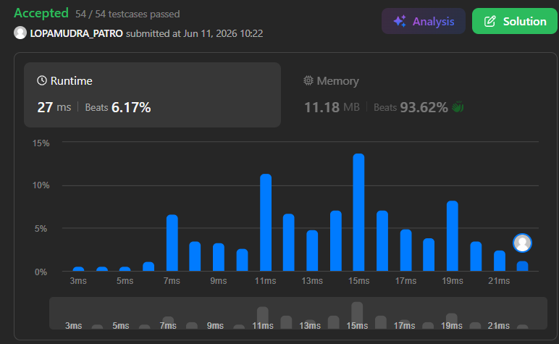

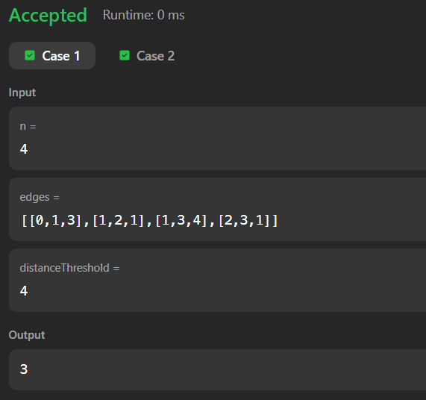
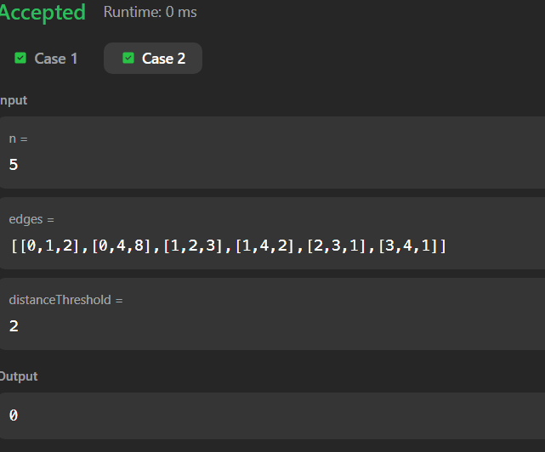

Lab program 8:
- Find Minimum Cost Spanning Tree of a given undirected graph using Prim’s algorithm.

SOURCE CODE
#include <stdio.h> #include <time.h>
void prims(int n,int graph[n][n]){ int visited[n];
for(int i=0;i<n;i++) visited[i]=0;
int edges=0; visited[0]=1; int cost=0;
printf("\nEdge\tWeight\n"); while(edges<n-1){
int min=100,x=-1,y=-1; for(int i=0;i<n;i++){
if(visited[i]==1){ for(int j=0;j<n;j++){
if(visited[j]==0 && graph[i][j]!=0){ if(graph[i][j]<min){
min=graph[i][j]; x=i;
y=j;
}
}
}
}
}

printf("%d - %d\t%d\n",x,y,graph[x][y]); cost+=graph[x][y];
visited[y]=1; edges++;
}
printf("\nMinimum Cost %d\n",cost);
}
int main(){ int n;
printf("\nEnter number of vertices: "); scanf("%d",&n);
int graph[n][n];
printf("\nEnter the adjacency matrix:\n"); for(int i=0;i<n;i++){
for(int j=0;j<n;j++){

scanf("%d",&graph[i][j]);
}
}
clock_t start=clock(); prims(n,graph); clock_t end=clock();
float time_taken=((float)(end-start))/CLOCKS_PER_SEC*1000; printf("\nTime taken: %.3f ms\n",time_taken);
return 0;
}

OUTPUT

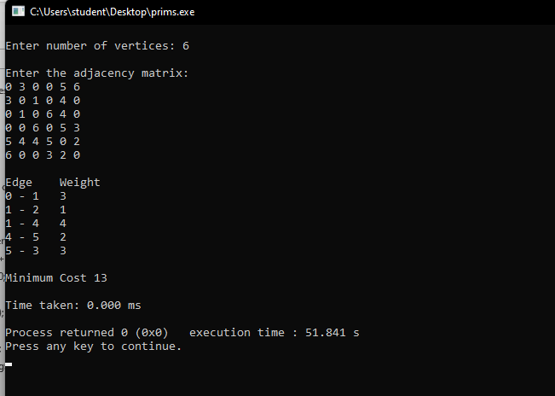

Lab program 8:
- Find Minimum Cost Spanning Tree of a given undirected graph using Kruskal’s algorithm.
SOURCE CODE

#include <stdio.h> #include <time.h> int parent[20];
int find(int i)
{
while(parent[i] != -1) i = parent[i];
return i;
}
void uni(int a, int b)
{
parent[b] = a;
}
int main()
{
int n, cost[20][20];
printf("Enter number of vertices: "); scanf("%d", &n);
printf("Enter adjacency matrix:\n"); for(int i = 0; i < n; i++)
{
for(int j = 0; j < n; j++)
{
scanf("%d", &cost[i][j]); if(cost[i][j] == 0)
cost[i][j] = 999;
}
}
for(int i = 0; i < n; i++) parent[i] = -1;
clock_t start = clock();
int edges = 0, mincost = 0; printf("\nEdge\tWeight\n"); while(edges < n - 1)
{
int min = 999; int a = -1, b = -1;
for(int i = 0; i < n; i++)
{
for(int j = 0; j < n; j++)
{
if(cost[i][j] < min)
{
min = cost[i][j]; a = i;

b = j;
}
}
}

int u = find(a); int v = find(b); if(u != v)
{
uni(u, v);
printf("%d - %d\t%d\n", a, b, min); mincost += min;
edges++;
}
cost[a][b] = cost[b][a] = 999;
}
clock_t end = clock();
printf("\nMinimum Cost = %d\n", mincost);
float time_taken =((float)(end - start) / CLOCKS_PER_SEC) * 1000; printf("Time Taken = %.3f ms\n", time_taken);
return 0;
}

OUTPUT
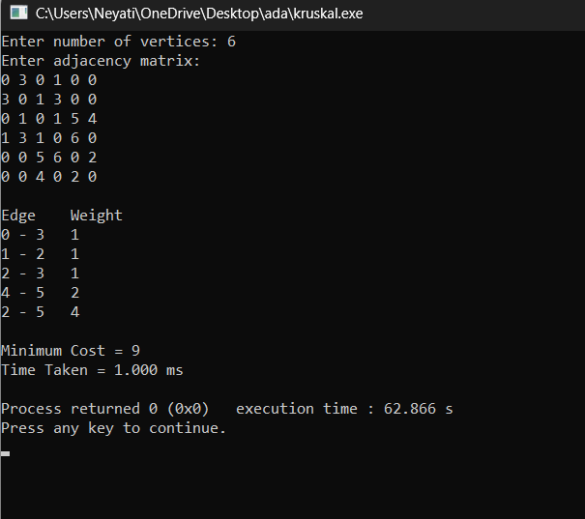

Lab program 9:
Implement Fractional Knapsack using Greedy technique.
SOURCE CODE
#include <stdio.h> #include <time.h> int main()
{
int n,m;
printf("Enter number of items: "); scanf("%d",&n);
int p[n],w[n];
float r[n],x[n]; printf("Enter profits: "); for(int i=0;i<n;i++)
scanf("%d",&p[i]); printf("Enter weights: "); for(int i=0;i<n;i++)
{
scanf("%d",&w[i]);
r[i]=(float)p[i]/w[i];
}
printf("Enter capacity: "); scanf("%d",&m);
clock_t start=clock(); for(int i=0;i<n-1;i++)
{
for(int j=0;j<n-i-1;j++)
{
if(r[j]<r[j+1])
{
float tr=r[j]; r[j]=r[j+1]; r[j+1]=tr; int tp=p[j]; p[j]=p[j+1]; p[j+1]=tp; int tw=w[j];
w[j]=w[j+1]; w[j+1]=tw;
}
}
}
for(int i=0;i<n;i++) x[i]=0;
float profit=0; int rem=m;
for(int i=0;i<n;i++)

{
if(w[i]<=rem)
{
x[i]=1;
profit+=p[i]; rem-=w[i];
}
else
{
x[i]=(float)rem/w[i]; profit+=x[i]*p[i]; break;
}
}
clock_t end=clock(); printf("\nProfit\tWeight\tRatio\tFraction\n"); for(int i=0;i<n;i++)
printf("%d\t%d\t%.2f\t%.2f\n", p[i],w[i],r[i],x[i]);
printf("\nMaximum Profit = %.2f\n",profit);
float time_taken=((float)(end-start))/CLOCKS_PER_SEC*1000; printf("Time Taken = %.3f ms\n",time_taken);
return 0;
}

OUTPUT
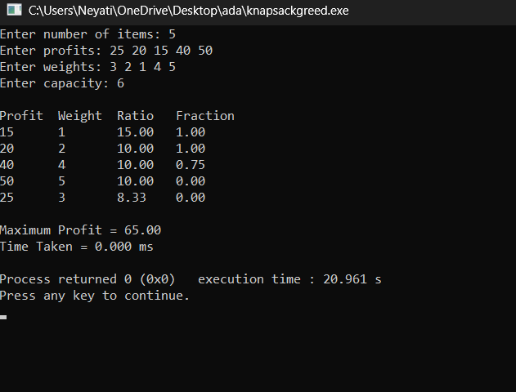

Lab program 10:
From a given vertex in a weighted connected graph, find shortest paths to other vertices using
Dijkstra’s algorithm.
SOURCE CODE
#include <stdio.h> #include <time.h> #define INF 999
int minDistance(int dist[], int visited[], int n)
{
int min = INF, min_index = -1; for(int i = 0; i < n; i++)
{
if(!visited[i] && dist[i] < min)
{
min = dist[i]; min_index = i;
}
}
return min_index;
}

int main()
{
int n, src;
printf("Enter number of vertices: "); scanf("%d", &n);
int cost[n][n];
printf("Enter adjacency matrix (0 if no edge):\n"); for(int i = 0; i < n; i++)
{
for(int j = 0; j < n; j++)
{
scanf("%d", &cost[i][j]); if(i != j && cost[i][j] == 0)
cost[i][j] = INF;
}
}
printf("Enter source vertex: "); scanf("%d", &src);
int dist[n], visited[n]; clock_t start = clock(); for(int i = 0; i < n; i++)
{
dist[i] = cost[src][i]; visited[i] = 0;
}
dist[src] = 0; visited[src]=1;

for(int i = 1; i < n; i++)
{
int u = minDistance(dist, visited, n); if(u == -1)
break; visited[u] = 1;
for(int v = 0; v < n; v++)
{
if(!visited[v] && cost[u][v] != INF &&
dist[u] + cost[u][v] < dist[v])
{
dist[v] = dist[u] + cost[u][v];
}
}
}
clock_t end = clock(); printf("\nVertex\tDistance\n"); for(int i = 0; i < n; i++)
printf("%d\t%d\n", i, dist[i]); float time_taken =
((float)(end - start) / CLOCKS_PER_SEC) * 1000; printf("\nTime Taken: %.3f ms\n", time_taken); return 0;
}

OUTPUT
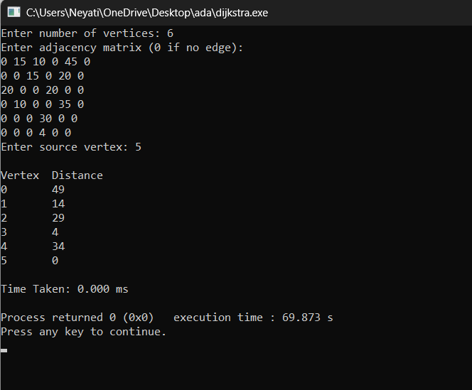

Lab program 11:
Implement “N-Queens Problem” using Backtracking.

SOURCE CODE
#include <stdio.h> #include <stdlib.h> #include <time.h>
int x[20], n, count = 0; int place(int k, int i)
{
for(int j = 1; j < k; j++)
{
if(x[j] == i || abs(x[j] - i) == abs(j - k)) return 0;
}
return 1;
}

void print()
{
count++;
printf("\nSolution %d:\n", count); for(int i = 1; i <= n; i++)
{
for(int j = 1; j <= n; j++)
{
if(x[i] == j)
printf("Q "); else
printf(". ");
}
printf("\n");
}
}
void nqueen(int k)
{
for(int i = 1; i <= n; i++)
{
if(place(k, i))
{
x[k] = i; if(k == n)
print(); else
nqueen(k + 1);
}
}
}

int main()
{
printf("Enter value of N: "); scanf("%d", &n);
clock_t start = clock(); nqueen(1);
clock_t end = clock(); if(count == 0)
printf("\nNo solution exists\n"); printf("\nTotal Solutions = %d\n", count); float time_taken =
((float)(end - start) / CLOCKS_PER_SEC) * 1000; printf("Time Taken = %.3f ms\n", time_taken); return 0;
}

OUTPUT
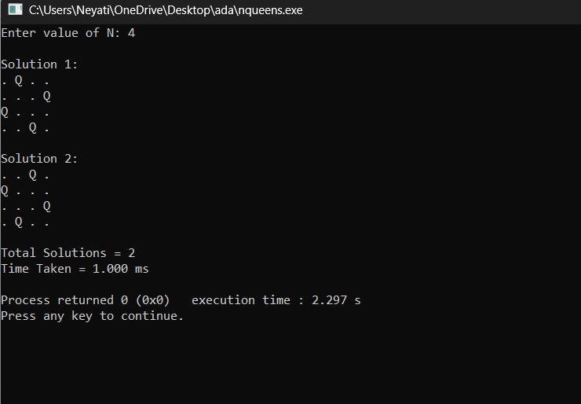

Leetcode exercises on Stacks, Queues, Circular Queues, Priority Queues.

Leetcode Problem 225. Implement Stack using Queues (Stack)

#include <stdlib.h>
#include <stdbool.h>

#define MAX 100

typedef struct {
int data[MAX];
int front, rear;
} Queue;

typedef struct {
Queue q1;
Queue q2;
} MyStack;

void initQueue(Queue *q) {
q->front = 0;
q->rear = -1;
}

bool isQueueEmpty(Queue *q) {
return q->front > q->rear;
}

void enqueue(Queue *q, int x) {
q->data[++q->rear] = x;
}

int dequeue(Queue *q) {
return q->data[q->front++];
}

int frontQueue(Queue *q) {
return q->data[q->front];
}

MyStack* myStackCreate() {
MyStack *s = (MyStack*)malloc(sizeof(MyStack));
initQueue(&s->q1);
initQueue(&s->q2);
return s;
}

void myStackPush(MyStack* obj, int x) {
enqueue(&obj->q2, x);

while (!isQueueEmpty(&obj->q1)) {
enqueue(&obj->q2, dequeue(&obj->q1));
}

Queue temp = obj->q1;
obj->q1 = obj->q2;
obj->q2 = temp;
}

int myStackPop(MyStack* obj) {
return dequeue(&obj->q1);
}

int myStackTop(MyStack* obj) {
return frontQueue(&obj->q1);
}

bool myStackEmpty(MyStack* obj) {
return isQueueEmpty(&obj->q1);
}

void myStackFree(MyStack* obj) {
free(obj);
}

OUTPUT

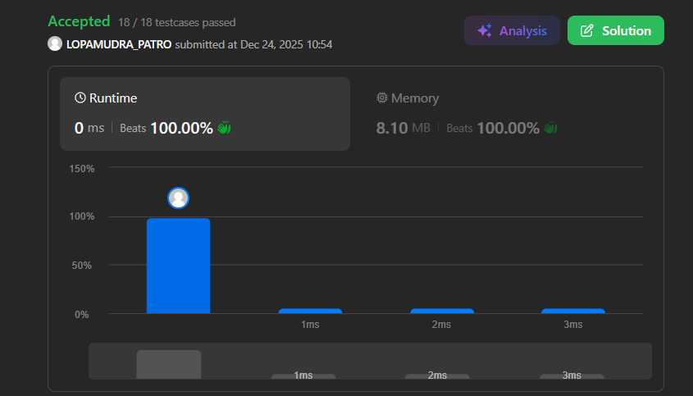

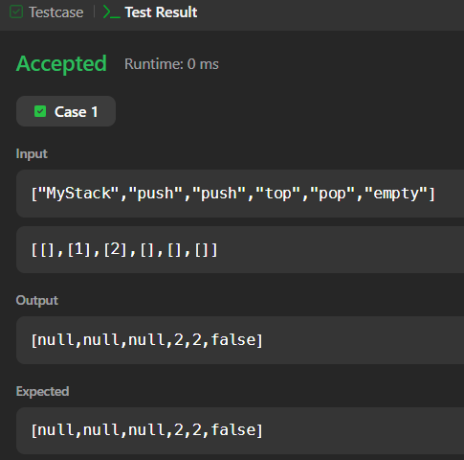

Leetcode Problem 232. Implement Queue Using Stacks (Queues)

#include <stdlib.h>
#include <stdbool.h>

#define MAX 100

typedef struct {
int data[MAX];
int top;
} Stack;

typedef struct {
Stack s1; // input stack
Stack s2; // output stack
} MyQueue;

void initStack(Stack *s) {
s->top = -1;
}

bool isStackEmpty(Stack *s) {
return s->top == -1;
}

void pushStack(Stack *s, int x) {
s->data[++s->top] = x;
}

int popStack(Stack *s) {
return s->data[s->top--];
}

int peekStack(Stack *s) {
return s->data[s->top];
}

MyQueue* myQueueCreate() {
MyQueue *q = (MyQueue*)malloc(sizeof(MyQueue));
initStack(&q->s1);
initStack(&q->s2);
return q;
}

void myQueuePush(MyQueue* obj, int x) {
pushStack(&obj->s1, x);
}

int myQueuePop(MyQueue* obj) {
if (isStackEmpty(&obj->s2)) {
while (!isStackEmpty(&obj->s1)) {
pushStack(&obj->s2, popStack(&obj->s1));
}
}
return popStack(&obj->s2);
}

int myQueuePeek(MyQueue* obj) {
if (isStackEmpty(&obj->s2)) {
while (!isStackEmpty(&obj->s1)) {
pushStack(&obj->s2, popStack(&obj->s1));
}
}
return peekStack(&obj->s2);
}

bool myQueueEmpty(MyQueue* obj) {
return isStackEmpty(&obj->s1) && isStackEmpty(&obj->s2);
}

void myQueueFree(MyQueue* obj) {
free(obj);
}

OUTPUT

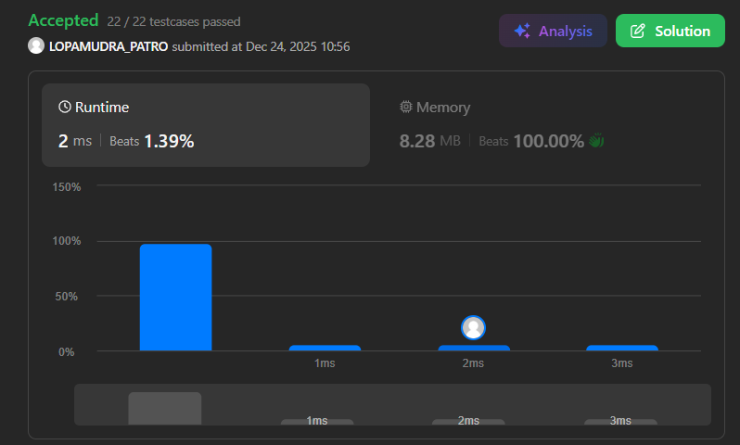
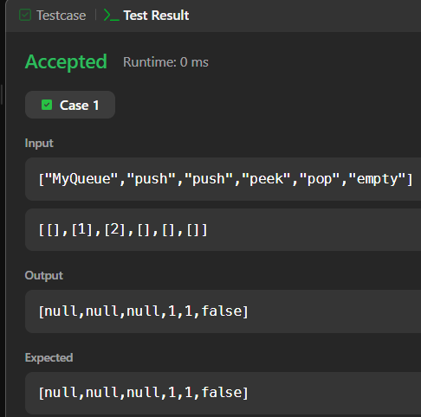

Leetcode Problem 622. Design Circular Queue (Circular Queues)

#include <stdlib.h>
#include <stdbool.h>

typedef struct {
int *arr;
int front;
int rear;
int size;
int capacity;
} MyCircularQueue;

MyCircularQueue* myCircularQueueCreate(int k) {
MyCircularQueue* q = (MyCircularQueue*)malloc(sizeof(MyCircularQueue));
q->capacity = k;
q->arr = (int*)malloc(k * sizeof(int));
q->front = 0;
q->rear = -1;
q->size = 0;
return q;
}

bool myCircularQueueEnQueue(MyCircularQueue* q, int value) {
if (q->size == q->capacity)
return false;

q->rear = (q->rear + 1) % q->capacity;
q->arr[q->rear] = value;
q->size++;
return true;
}

bool myCircularQueueDeQueue(MyCircularQueue* q) {
if (q->size == 0)
return false;

q->front = (q->front + 1) % q->capacity;
q->size--;
return true;
}

int myCircularQueueFront(MyCircularQueue* q) {
if (q->size == 0)
return -1;
return q->arr[q->front];
}

int myCircularQueueRear(MyCircularQueue* q) {
if (q->size == 0)
return -1;
return q->arr[q->rear];
}

bool myCircularQueueIsEmpty(MyCircularQueue* q) {
return q->size == 0;
}

bool myCircularQueueIsFull(MyCircularQueue* q) {
return q->size == q->capacity;
}

void myCircularQueueFree(MyCircularQueue* q) {
free(q->arr);
free(q);
}

OUTPUT

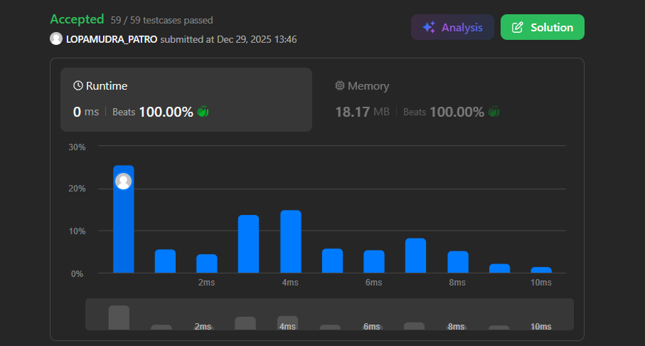

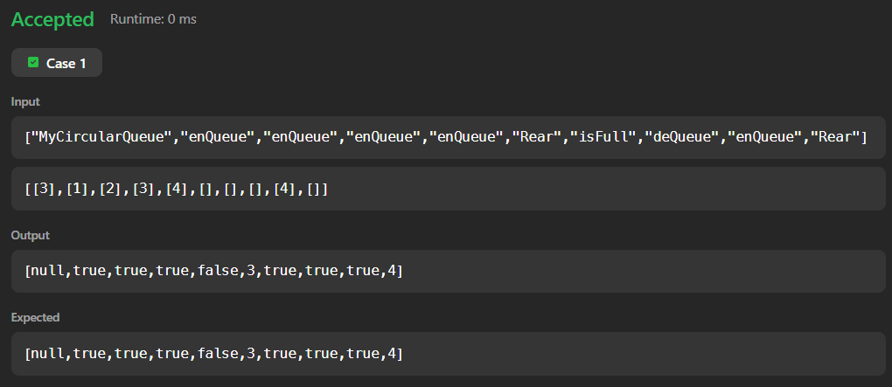

Leetcode Problem 743. Network Delay Time (Priority Queues)

#include <stdlib.h>

#include <limits.h>

int networkDelayTime(int** times, int timesSize, int* timesColSize, int n, int k) {

// Create adjacency matrix

int graph[101][101];

for (int i = 1; i <= n; i++) {

for (int j = 1; j <= n; j++) {

graph[i][j] = INT_MAX;

}

}

for (int i = 0; i < timesSize; i++) {

int u = times[i][0];

int v = times[i][1];

int w = times[i][2];

graph[u][v] = w;

}

int dist[101];

int visited[101];

for (int i = 1; i <= n; i++) {

dist[i] = INT_MAX;

visited[i] = 0;

}

dist[k] = 0;

for (int i = 1; i <= n; i++) {

int u = -1;

for (int j = 1; j <= n; j++) {

if (!visited[j] &&

(u == -1 || dist[j] < dist[u])) {

u = j;

}

}

if (dist[u] == INT_MAX)

break;

visited[u] = 1;

for (int v = 1; v <= n; v++) {

if (graph[u][v] != INT_MAX &&

dist[u] + graph[u][v] < dist[v]) {

dist[v] = dist[u] + graph[u][v];

}

}

}

int ans = 0;

for (int i = 1; i <= n; i++) {

if (dist[i] == INT_MAX)

return -1;

if (dist[i] > ans)

ans = dist[i];

}

return ans;

}

OUTPUT
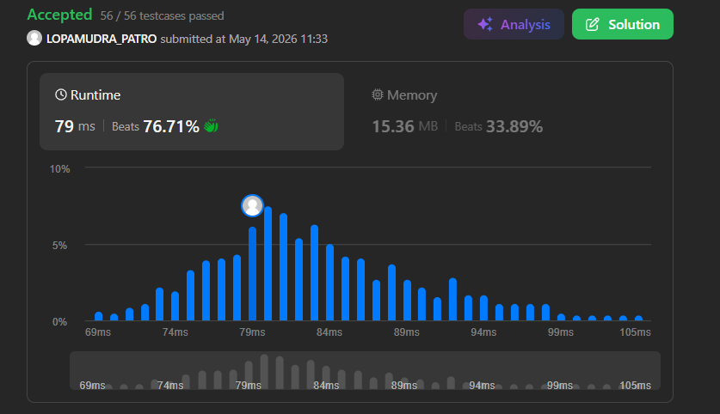

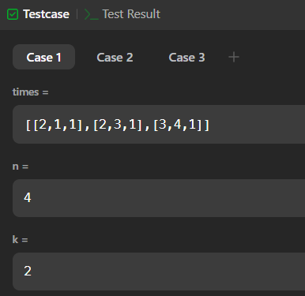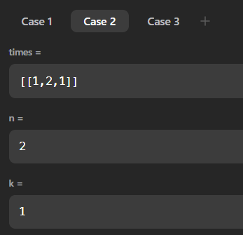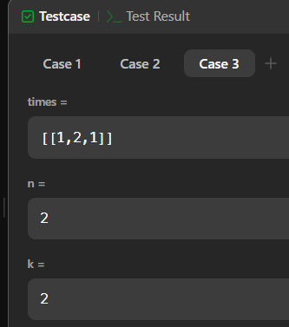

Leetcode exercises on DFS, BFS

Leetcode Problem 847. Shortest Path Visiting All Nodes (BFS)

#include <stdlib.h>
#include <stdbool.h>

typedef struct {
int node;
int mask;
int dist;
} State;

int shortestPathLength(int** graph, int graphSize, int* graphColSize) {

int finalMask = (1 << graphSize) - 1;
bool visited[12][4096] = {false};

State queue[50000];

int front = 0;
int rear = 0;

for (int i = 0; i < graphSize; i++) {

int mask = (1 << i);

queue[rear++] = (State){i, mask, 0};

visited[i][mask] = true;
}

while (front < rear) {

State curr = queue[front++];

int node = curr.node;
int mask = curr.mask;
int dist = curr.dist;
if (mask == finalMask)
return dist;

for (int i = 0; i < graphColSize[node]; i++) {

int next = graph[node][i];

int nextMask = mask | (1 << next);

if (!visited[next][nextMask]) {

visited[next][nextMask] = true;

queue[rear++] = (State){
next,
nextMask,
dist + 1
};
}
}
}

return -1;
}

OUTPUT

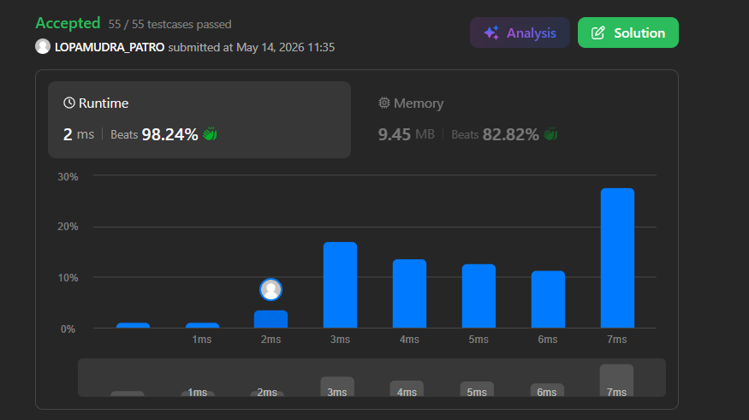

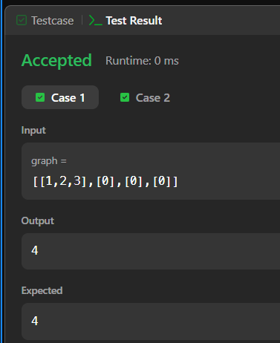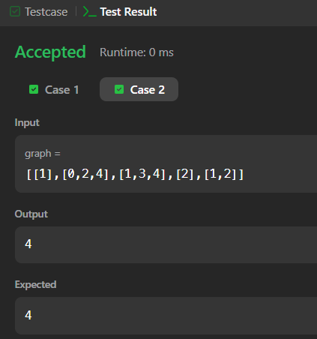

Leetcode 3558. Number of Ways to Assign Edge Weights I (DFS)

#define MOD 1000000007LL

long long power(long long a, long long b) {
long long res = 1;

while (b > 0) {
if (b & 1)
res = (res * a) % MOD;

a = (a * a) % MOD;
b >>= 1;
}

return res;
}

int assignEdgeWeights(int** edges, int edgesSize, int* edgesColSize) {
int n = edgesSize + 1;

int degree[n + 1];
for (int i = 0; i <= n; i++)
degree[i] = 0;

for (int i = 0; i < edgesSize; i++) {
degree[edges[i][0]]++;
degree[edges[i][1]]++;
}

int* adj[n + 1];
for (int i = 1; i <= n; i++)
adj[i] = (int*)malloc(degree[i] * sizeof(int));

int idx[n + 1];
for (int i = 0; i <= n; i++)
idx[i] = 0;

for (int i = 0; i < edgesSize; i++) {
int u = edges[i][0];
int v = edges[i][1];

adj[u][idx[u]++] = v;
adj[v][idx[v]++] = u;
}

int q[n + 1];
int depth[n + 1];
int vis[n + 1];

for (int i = 0; i <= n; i++)
vis[i] = 0;

int front = 0, rear = 0;

q[rear++] = 1;
vis[1] = 1;
depth[1] = 0;

int maxDepth = 0;

while (front < rear) {
int node = q[front++];

if (depth[node] > maxDepth)
maxDepth = depth[node];

for (int i = 0; i < degree[node]; i++) {
int nei = adj[node][i];

if (!vis[nei]) {
vis[nei] = 1;
depth[nei] = depth[node] + 1;
q[rear++] = nei;
}
}
}

for (int i = 1; i <= n; i++)
free(adj[i]);

if (maxDepth == 0)
return 0;

return (int)power(2, maxDepth - 1);
}

OUTPUT

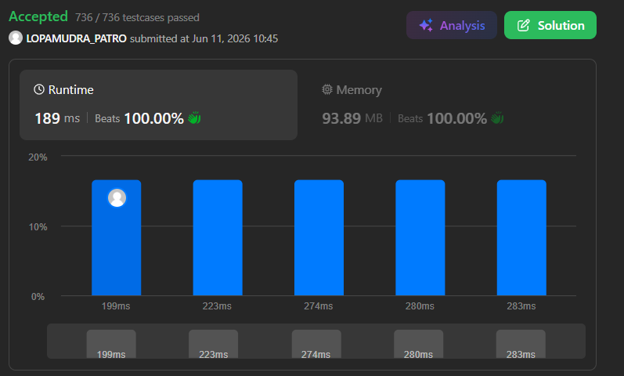

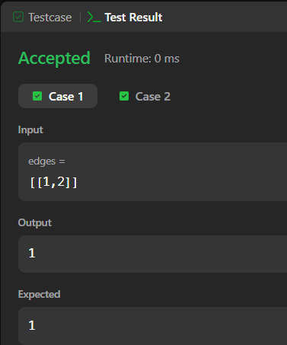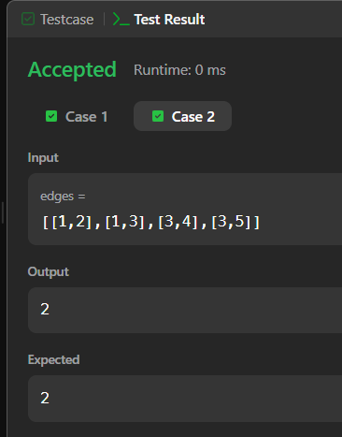

Leetcode exercises on Trees and Graphs

Leetcode 493. Reverse Pairs (Trees)
#include <stdlib.h>

int mergeSort(int* nums, int left, int right);
int merge(int* nums, int left, int mid, int right);

int reversePairs(int* nums, int numsSize) {
if (numsSize == 0)
return 0;

return mergeSort(nums, 0, numsSize - 1);
}

int mergeSort(int* nums, int left, int right) {
if (left >= right)
return 0;

int mid = left + (right - left) / 2;

int count = 0;

count += mergeSort(nums, left, mid);
count += mergeSort(nums, mid + 1, right);

count += merge(nums, left, mid, right);

return count;
}

int merge(int* nums, int left, int mid, int right) {
int count = 0;

// Count reverse pairs
int j = mid + 1;

for (int i = left; i <= mid; i++) {
while (j <= right && (long long)nums[i] > 2LL * nums[j]) {
j++;
}

count += (j - (mid + 1));
}

int size = right - left + 1;
int* temp = (int*)malloc(size * sizeof(int));

int i = left;
j = mid + 1;
int k = 0;

while (i <= mid && j <= right) {
if (nums[i] <= nums[j]) {
temp[k++] = nums[i++];
} else {
temp[k++] = nums[j++];
}
}

while (i <= mid) {
temp[k++] = nums[i++];
}

while (j <= right) {
temp[k++] = nums[j++];
}

for (i = left, k = 0; i <= right; i++, k++) {
nums[i] = temp[k];
}

free(temp);

return count;
}

OUTPUT

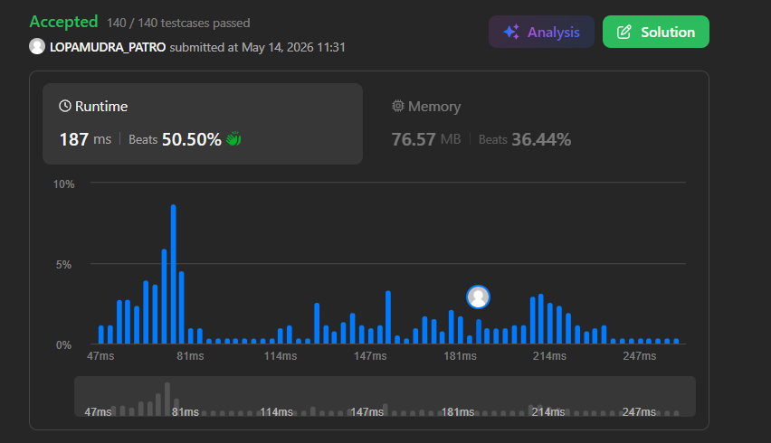
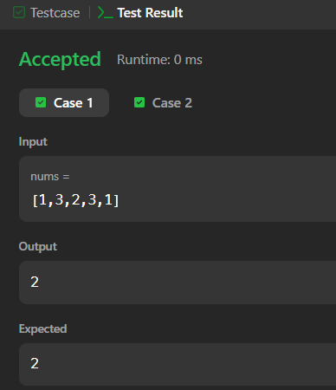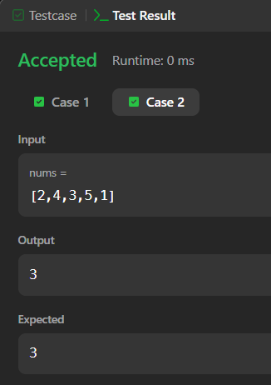

Leetcode Problem 133. Clone Graph (Graphs)

struct Node* map[101];

struct Node* dfs(struct Node* node) {
if (node == NULL)
return NULL;

if (map[node->val] != NULL)
return map[node->val];

struct Node* clone = (struct Node*)malloc(sizeof(struct Node));
clone->val = node->val;
clone->numNeighbors = node->numNeighbors;
clone->neighbors = (struct Node**)malloc(
clone->numNeighbors * sizeof(struct Node*)
);

map[node->val] = clone;

for (int i = 0; i < node->numNeighbors; i++) {
clone->neighbors[i] = dfs(node->neighbors[i]);
}

return clone;
}

struct Node *cloneGraph(struct Node *s) {
if (s == NULL)
return NULL;

for (int i = 0; i < 101; i++)
map[i] = NULL;

return dfs(s);
}

OUTPUT
